Insertion Sort Assignments Average Case
A[1..n] contains numbers 1 through n, and all elements of A are distinct. And n! Of numbers 1,2,...,n is equally likely. If element on ith position suppose to be in jth position when j is between 1 to i-1, then number of assignments for j to move to i is i-j+2. If i=j no assignments are needed. It is i-j+2 assignments because all elements between i and j has to move 1 spot which in total (i-j) and element on ith position has to be assigned on a temporary variable and assigned on its correct place (i-j+2).

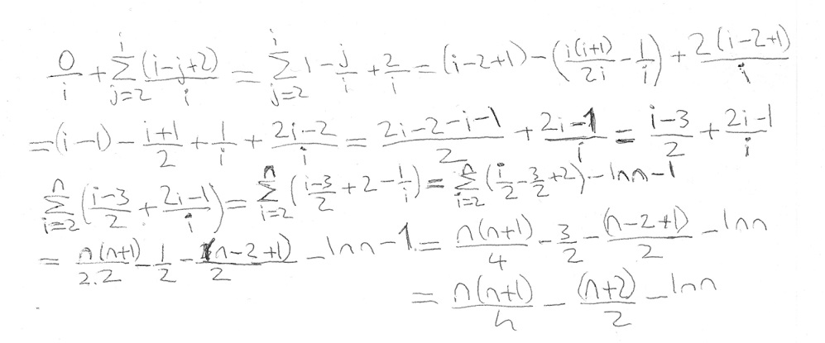
Selection Sort 2 Average Case
If A[1..n] contains numbers 1 through n, and all elements of A are distinct. And n! Of numbers 1,2,...,n is equally likely. If ith element on its correct position at the start we won't do any assignments. If it isn't we will do 3 assignments to swap positions.Chance of it being on correct position increases everytime we approach to the end of the sort since exchanges we did has a chance of puting elements on correct order.
n-1
3*∑ 1/i = 3ln(n-1)
i=1

